BCN LAB-1
24K-2040
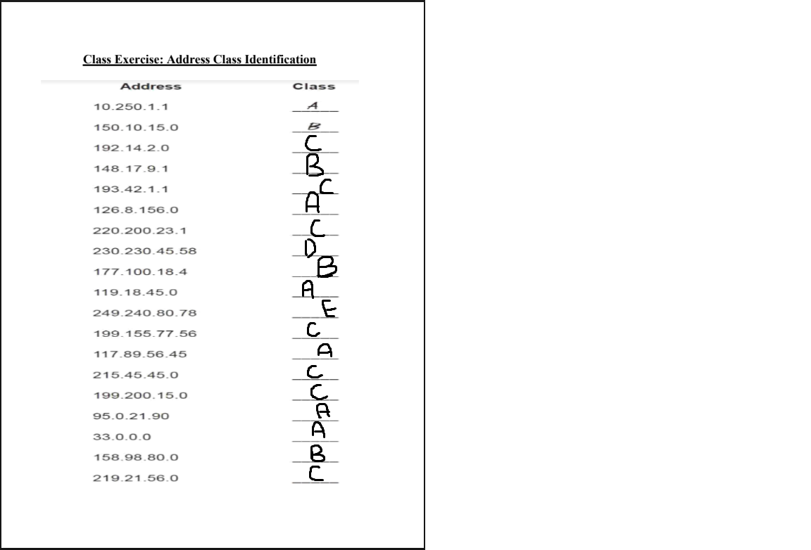
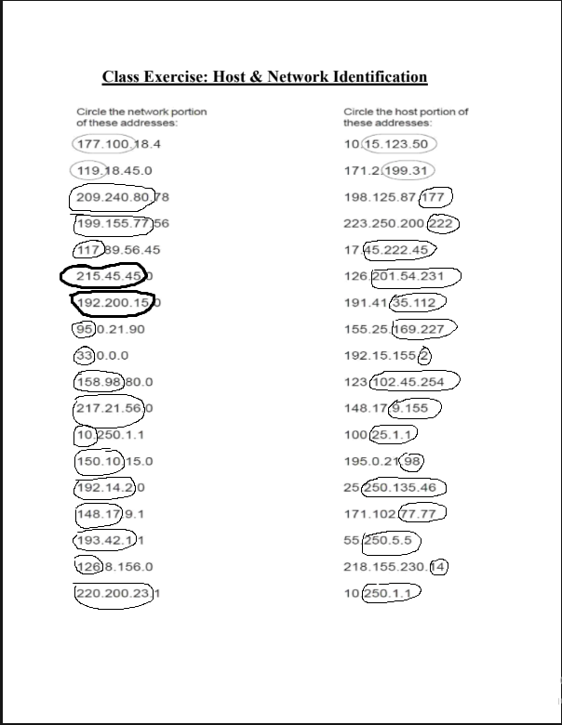
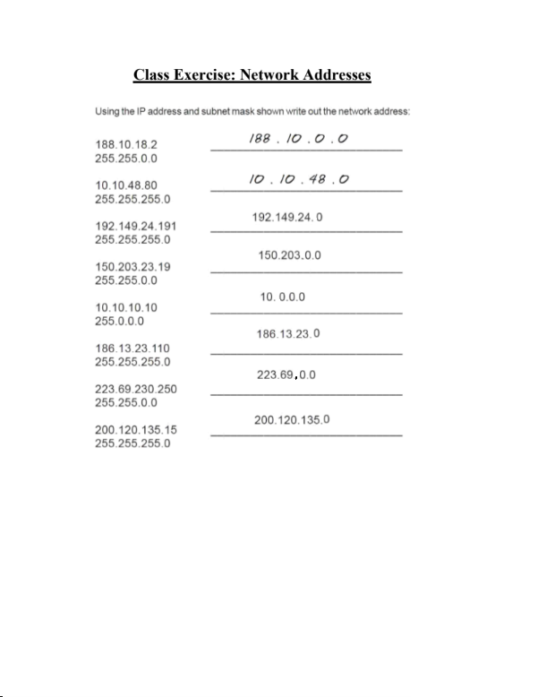
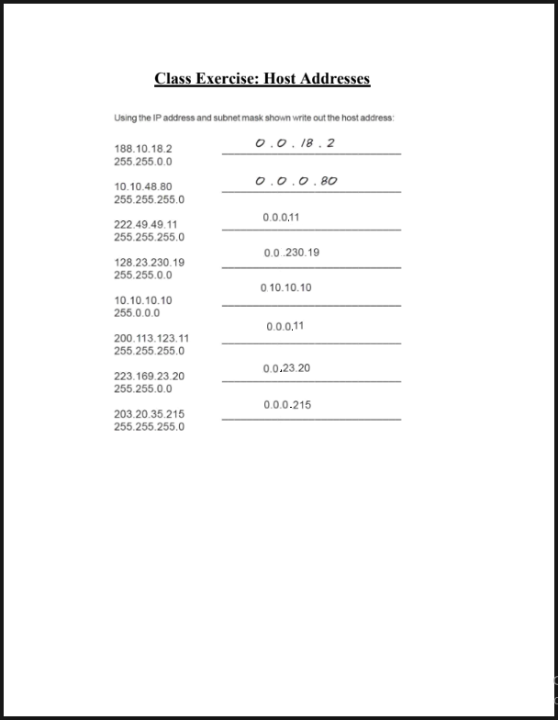
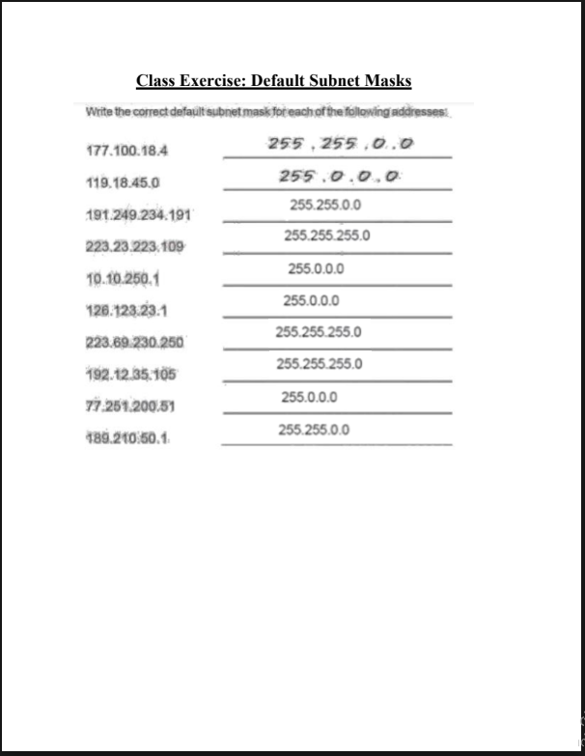
Tasks
(Attach screenshot of command prompt/terminal where you are using it.)
1) Find the IP address of the computer you are currently using.
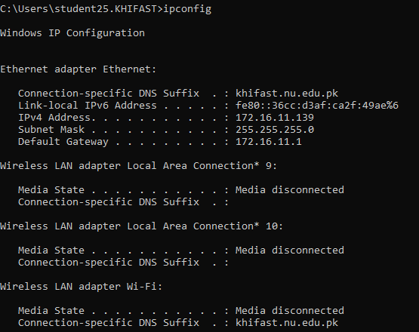

2) Find the IP address of the computer you are currently using, plus MAC address, the gateway, plus
whether DHCP is turned on.
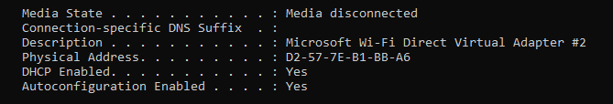

3) Display the host name of the computer.
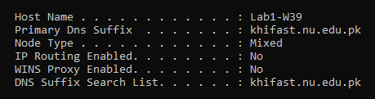
4) Check for basic IP connectivity between two computers by name and IP address. How can basic IP
connectivity be checked? What are the reasons why there is no connectivity?
ping google.com
reason: incorrect IP address.
5) Find out which ports on your host are connected to applications. Connect the browser to some
external web page before running the appropriate command.
Command: netstat -an
Reason: Shows active connections and listening ports.
6) Find the path of routers to www.google.com.What is its IP address? How many hops involved in the
path?
Command: tracert google.com
Reason: Displays the route taken and IP address of destination
7) A ping to 192.168.0.2 works but a ping to the machine’s name “blue machine” fails. What could be
wrong?
Reason: DNS resolution Problem or the host name is not configured
8) Which type of cable will you use to connect in a normal home installation?
Answer: Straight through Ethernet cable
9) Can you connect a Switch to another Switch or a router to a PC using a straight- through cable?
Explain your answer.
Answer: Yes, modern devices support auto MDIX which automatically adjusts transmit pairs
10) Write a brief report on your home network or any organizational network including topology, 1 page
max.
Answer: A typical home network uses a star topology where all devices connect to a central wireless router. The router connects to the ISP modem and provides internet access. Devices such as PC’s connect via Ethernet cables or WIFI. The router assigns IP address using DHCP and performs NAT for internet access. Security is provided through WPA3 encryption and basic firewall. This setup is simple, cost effective, suitable for small networks.

